LESSON 4.
Microbiology diagnosis of gastro-intestinal bacterial diseases (dysentery, cholera, campylobacteriosis, helicobacteriosis)
LESSON PLAN:
• Shigella, morpho-biological characteristics.
• Pathogenesis and clinical manifestations of bacterial dysentery
• Microbiological diagnosis of bacterial dysentery, determination of bacterial carriage.
• Specific treatment and prevention of bacterial dysentery.
• Mechanism of resistance to broad-spectrum beta-lactamase.
• General properties, classification, biovars and serovars of vibrios
• Morpho-biological characteristics of cholera vibrios.
• Differentiation of cholerae, El-Tor biovars and vibrios from serogroup O139.
• Pathogenesis and clinical manifestations of cholera
• Microbiological diagnosis of cholera.
• Specific treatment and prevention of cholera
• Morpho-biological characteristics of Campylobacter, pathogenesis and clinical manifestations of diseases caused by it
• Microbiological diagnosis of campylobacteriosis
• Helicobacter pylori, morpho-biological characteristics, pathogenicity factors, role in the pathogenesis of gastritis, gastric and duodenal ulcers, gastric cancer and MALT-lymphoma
• Microbiological diagnosis of helicobacteriosis, application of invasive and non-invasive examination methods. Urease breath test (UNT)

SHIGELLA
Trigger Words
Gastroenteritis, dysentery, Shiga toxin

Biology and Virulence
Gram-negative, facultatively anaerobic rods
Fermenter; oxidase negative
Lipopolysaccharide consists of somatic O polysaccharide, core polysaccharide (common antigen), and lipid A (endotoxin)
Four species recognized: S. sonnei responsible for most infections in developed countries, S. flexneri for infections in developing countries, S.dysenteriae for the most severe infections, and S.boydii not commonly isolated
Virulence: exotoxin (Shiga toxin) produced by S. dysenteriae disrupts protein synthesis and produces endothelial damage

Epidemiology
Humans are the only reservoir for these bacteria
Disease spread person to person by fecal-oral route
Patients at highest risk for disease are young children in day-care centers, nurseries, and custodial institutions; siblings and parents of these children; male homosexuals
Relatively few organisms can produce disease (highly infectious)
Disease occurs worldwide with no seasonal incidence (consistent with person-to-person spread involving a low inoculum)

Diseases
Disease: most common form of disease is gastroenteritis (shigellosis), an initial watery diarrhea progressing within 1 to 2 days to abdominal cramps and tenesmus (with or without bloody stools); severe form of disease is caused by S. dysenteriae (bacterial dysentery); asymptomatic carriage develops in a small number of patients (reservoir for future infections)

Diagnosis
ᑏᑏ Isolation from stool specimens requires use of selective media
ᑏᑏ Enteric multiplex NAATs considered gold standard diagnostic

Treatment, Prevention, and Control
Antibiotic therapy shortens the course of symptomatic disease and fecal shedding
Treatment should be guided by in vitro susceptibility tests
Empirical therapy can be initiated with a fluoroquinolone or trimethoprim, sulfamethoxazole
Appropriate infection control measures should be instituted to prevent spread of the organism, including hand washing and proper disposal of soiled linens
Vibrio and Related Bacteria
VIBRIO CHOLERAE
Trigger Words
Serogroup O1, cholera, cholera toxin, shellfish, gastroenteritis

Biology and Virulence
Curved gram-negative rods
Fermentative, facultative anaerobic; require salt for growth
Strains subdivided into more than 200 serogroups (O–cell wall antigens)
V. cholerae serogroup O1 is further subdivided into serotypes (Inaba, Ogawa, and Hikojima) and biotypes (Classical and El Tor)
Disease mediated by cholera toxin (complex A-B toxin) and toxin coregulated pilus

Epidemiology
Serotype O1 is responsible for major pandemics (worldwide epidemics), with significant mortality in developing countries; O139 can cause similar diseases
Organism found in estuarine and marine environments worldwide (including along the coast of the United States); associated with chitinous shellfish
Organism can multiply freely in water
Bacterial levels in contaminated waters increase during the warm months
Most commonly spread by consumption of freshly contaminated water
Direct person-to-person spread is rare because the infectious dose is high; the infectious dose is high because most organisms are killed by stomach acids

Diseases
Infection can range from asymptomatic colonization or mild diarrhea to severe, rapidly fatal diarrhea

The Medically Important Vibrios
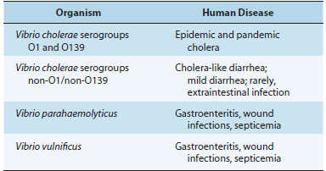

Diagnosis
ᑏᑏMicroscopic examination of stool can be useful in acute infections in the setting of an epidemic but rapidly becomes negative as the disease progresses
ᑏᑏ Immunoassays for cholera toxin or O1 and O139 lipopolysaccharides can be useful, although the analytical performance of the assays is quite variable
ᑏᑏMultiplex nucleic acid amplification tests can be used to detect many enteric pathogens (bacteria, viruses, and parasites) and are the diagnostic test of choice
ᑏᑏCulture should be performed early in course of disease with fresh stool specimens maintained in a neutral to alkaline pH

Treatment, Prevention, and Control
Fluid and electrolyte replacement are crucial
Antibiotics (e.g., azithromycin) reduce the bacterial burden and exotoxin production, as well as duration of diarrhea
Improved hygiene is critical for control
Combination inactivated whole cell and cholera toxin B subunit vaccines provide limited protection and herd immunity

VIBRIO PARAHAEMOLYTICUS
Trigger Words
Kanagawa hemolysin, shellfish, gastroenteritis

Biology and Virulence
Curved gram-negative rods
Fermentative, facultative anaerobic; require salt for growth
Production of thermostable direct hemolysin (Kanagawa hemolysin) associated with pathogenic strains

Epidemiology
Organism found in estuarine and marine environments worldwide
Associated with consumption of contaminated raw shellfish
Most common cause of bacterial gastroenteritis in Japan and Southeast Asia
Most common cause of seafood-associated gastroenteritis in United States

Diseases
Most symptomatic infections are selflimited diarrhea

Treatment, Prevention, and Control
Self-limited disease, although antibiotics can shorten length of symptoms and fluid loss
Disease prevented by proper cooking of shellfish
No vaccine is available

VIBRIO VULNIFICUS
Trigger Words
Septicemia, wound infections, hepatic disease

Biology and Virulence
Curved gram-negative rods
Fermentative, facultative anaerobic; require salt for growth
Virulence associated with presence of polysaccharide capsule and hydrolytic enzymes

Epidemiology
Infection associated with exposure of a wound to contaminated salt water or ingestion of improperly prepared shellfish

Diseases
High mortality associated with primary septicemia and wound infections, particularly in patients with underlying hepatic disease

Diagnosis
ᑏᑏCulture wounds and blood

Treatment, Prevention, and Control
Life-threatening illnesses that must be promptly treated with antibiotics
Minocycline or doxycycline combined with a ceftriaxone or cefotaxime is the treatment of choice
No vaccine is available

Important Vibrio and Aeromonas Species
Vibrio vibrio, move rapidly or vibrate (rapid movement caused by polar flagella)
V. cholerae cholera, cholera or an intestinal disease
V. parahaemolyticus para, by the side of; haema, blood; lyticus, dissolving (dissolving blood; Kanagawa toxin–positive strains are hemolytic)
V. vulnificus vulnificus, inflicting wounds (associated with prominent wound infections)

Aeromonas aero, gas or air; monas, unit or monad (gasproducing bacteria)
A. caviae cavia, guinea pig (first isolated in guinea pigs)
A. hydrophila hydro, water; phila, loving (water loving)
A. veronii veron, named after the bacteriologist Veron
Vibrio Species Most Commonly Associated with Human Disease
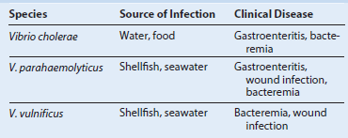

Virulence Factors of Vibrio Species
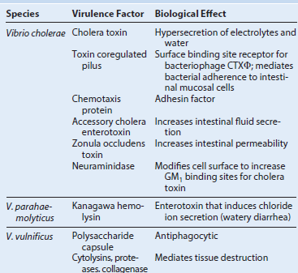

Vibrio cholerae
Cholera: it begins with an abrupt onset of watery diarrhea and vomiting and can progress to severe dehydration, metabolic
acidosis and hypokalemia, and hypovolemic shock.
Gastroenteritis: milder forms of diarrheal disease can occur in toxin-negative strains of V. cholerae O1 and in non-O1 serotypes.

Vibrio parahaemolyticus
Gastroenteritis: it is generally self-limited, with an explosive onset of watery diarrhea and nausea, vomiting, abdominal cramps, headache, and low-grade fever.
Wound infection: it is associated with exposure to contaminated water.

Vibrio vulnificus
Wound infection: severe, potentially fatal infections characterized by erythema, pain, bullae formation, tissue necrosis, and septicemia.

CAMPYLOBACTER
Trigger Words
Curved rods, gastroenteritis, Guillain-Barré syndrome

Biology and Virulence
Thin, curved, gram-negative rods
ᑏ Factors that regulate adhesion, motility, and invasion into intestinal mucosa are poorly defined

Epidemiology
Zoonotic infection; improperly prepared poultry is a common source of human infections
Infections acquired by ingestion of contaminated food, unpasteurized milk, or contaminated water
Person-to-person spread is unusual
Dose required to establish disease is high unless the gastric acids are neutralized or absent
Worldwide distribution with enteric infections seen throughout the year

Diseases
Most common disease is acute enteritis with diarrhea, malaise, fever, and abdominal pain
Guillain-Barré syndrome is believed to be an autoimmune disease caused by antigenic cross-reactivity between oligosaccharides in the bacterial capsule and glycosphingolipids on the surface of neural tissues
Most infections are self-limited but can persist for a week or more
C. fetus is associated with septicemia and is disseminated to multiple organs

Diagnosis
ᑏᑏMicroscopic detection of thin, S-shaped, gram-negative rods in stool specimens is specific but insensitive
ᑏᑏCommercial multiplex nucleic acid amplification assays are highly sensitive and specific for enteric pathogens and particularly useful for detection of C. jejuni and C. coli infections
ᑏᑏCulture requires use of specialized media incubated with reduced oxygen, increased carbon dioxide, and (for thermophilic species) elevated temperatures requires incubation for 2 or more days and is relatively insensitive unless fresh media are used
ᑏᑏDetection of Campylobacter antigens instool specimens is moderately sensitive and very specific compared with culture

Treatment, Prevention, and Control
For gastroenteritis, infection is self-limited and is managed by fluid and electrolyte replacement
Severe gastroenteritis and septicemia are treated with erythromycin or azithromycin
Gastroenteritis is prevented by proper preparation of food and consumption of pasteurized milk; preventing contamination of water supplies also controls infection
Experimental vaccines targeting the outer capsular polysaccharides are promising for control of infections in animal reservoirs

HELICOBACTER PYLORI
Trigger Words
Gastritis, peptic ulcers, gastric cancer, lymphoid tissue lymphoma, urease

Biology and Virulence
Curved gram-negative rods
Urease production at very high levels is typical of gastric helicobacters (e.g., H. pylori; important diagnostic test for H. pylori) and uncommon in intestinal helicobacters
Multiple factors contribute to gastric colonization, inflammation, alteration of gastric acid production, and tissue destruction

Epidemiology
Infections are common, particularly in people in a low socioeconomic class or in developing nations
Humans are the primary reservoir
Person-to-person spread is important (typically fecal-oral)
Ubiquitous and worldwide, with no seasonal incidence of disease

Diseases
H. pylori is an important cause of acute and chronic gastritis, peptic ulcers, gastric adenocarcinoma, and mucosa associated Lymphoid tissue lymphoma

Diagnosis
ᑏᑏMicroscopy: histologic examination of biopsy specimens is sensitive and specific
ᑏᑏUrease test relatively sensitive and highly specific; urea breath test is a noninvasive test
ᑏᑏH. pylori antigen test is sensitive and specific; performed with stool specimens
ᑏᑏCulture requires incubation in microaerophilic conditions; growth is slow; relatively insensitive unless multiple biopsies are cultured
ᑏᑏ Serology useful for demonstrating exposure to H. pylori

Treatment, Prevention, and Control
Multiple regimens have been evaluated for treatment of H. pylori infections. Combined therapy with a proton pump inhibitor (e.g., omeprazole), a macrolide (e.g., clarithromycin), and a _-lactam (e.g., amoxicillin) for 2 weeks has had a high success rate
Prophylactic treatment of colonized individuals has not been useful and potentially has adverse effects, such as predisposing patients to adenocarcinomas of the lower esophagus
Human vaccines are not currently available

Important Campylobacter and Helicobacter Species
Campylobacter kampylos, curved; bacter, rod (a curved rod)
C. jejuni jejuni, of the jejunum
C. coli coli, of the colon
C. fetus fetus, refers to the initial observation that these bacteria caused fetal infections
C. upsaliensis upsaliensis, original isolates recovered fromthe feces of dogs at an animal clinic in Uppsala, Sweden
Helicobacter helix, spiral; bacter, rod (a spiral rod)
H. pylori pylorus, lower part of the stomach
H. cinaedi cinaedi, of a homosexual (the organism was first isolated from homosexuals withgastroenteritis)
H. fennelliae fennelliae, named after C. Fennell, who first
isolated the organism

Common Campylobacter Species Associated with Human Disease

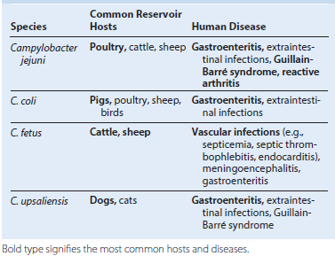

Helicobacter Species Associated with Human Disease
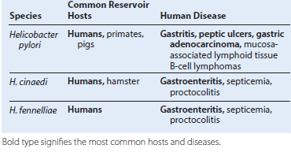

Rapid, Presumptive Identification of Gram-Negative Enteric Bacteria
Lactose fermented rapidly
Escherichia coli: metallic sheen on differential media; motile; flat, nonviscous colonies
Enterobacter aerogenes: raised colonies, no metallic sheen; often motile; more viscous growth
Enterobacter cloacae: similar to Enterobacter aerogenes
Klebsiella pneumoniae: very viscous, mucoid growth; nonmotile
Lactose fermented slowly
Edwardsiella, Serratia, Citrobacter, Arizona, Providencia, Erwinia
Lactose not fermented
Shigella species: nonmotile; no gas from dextrose
Salmonella species: motile; acid and usually gas from dextrose
Proteus species: “swarming” on agar; urea rapidly hydrolyzed (smell of ammonia)
Pseudomonas species (see Chapter 16): soluble pigments, blue-green and fluorescing; sweetish smell

